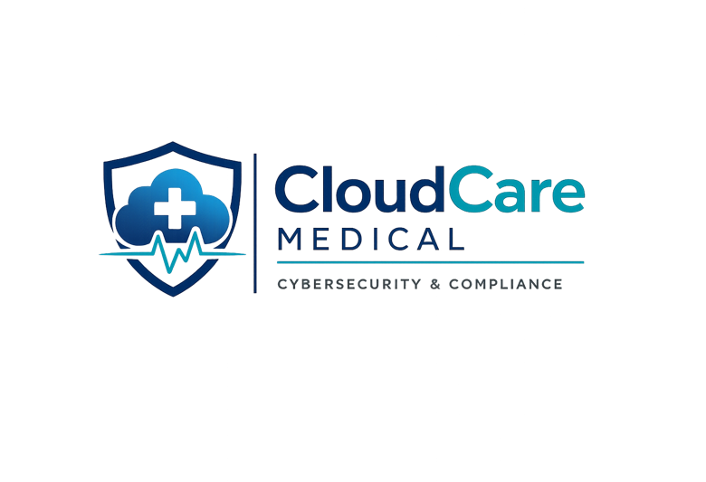
Risk Management Plan
Version 1.0
Cybersecurity Governance & Compliance Documentation

Prepared by: Alaa Mohamed Abdeltatif
Aspiring GRC Analyst
ISO/IEC 27001 Security Governance Portfolio 2026

Executive Summary
This Risk Management Plan has been developed for CloudCare Medical to identify, assess, and manage cybersecurity and compliance risks associated with healthcare information systems and sensitive patient data.

The purpose of this document is to establish a structured approach to risk governance, strengthen data protection practices, and support compliance with recognised cybersecurity standards including ISO/IEC 27001 principles.

This plan outlines identified risks, risk impact levels, mitigation strategies, responsible stakeholders, and ongoing monitoring procedures to improve organisational security posture and operational resilience.

Table of Contents
1. Executive Summary ........................................ 2

2. Purpose & Scope .......................................... 4

3. Risk Assessment Methodology .............................. 5

4. Risk Identification ...................................... 6

5. Risk Analysis & Impact Assessment ........................ 7

6. Risk Treatment Plan ...................................... 8

7. Roles & Responsibilities ................................ 9

8. Compliance & Regulatory Requirements .................... 10

9. Monitoring & Review ..................................... 11

10. Conclusion ............................................. 12

Purpose & Scope
Purpose

The purpose of this Risk Management Plan is to establish a formal framework for identifying, assessing, managing, and monitoring cybersecurity and compliance risks within CloudCare Medical.

This document supports the organisation’s commitment to protecting sensitive healthcare information, maintaining operational continuity, and aligning with recognised cybersecurity governance standards and best practices.

Scope

This Risk Management Plan applies to all systems, applications, employees, contractors, third-party service providers, and data handling processes associated with CloudCare Medical.

The scope includes:
- Electronic healthcare information systems
- Patient data storage and transmission
- Cloud-based medical platforms
- Internal network infrastructure
- Employee access control procedures
- Regulatory and compliance obligations

Risk Assessment Methodology

Risk Assessment Approach
CloudCare Medical follows a structured risk assessment methodology aligned with ISO/IEC 27001 principles to identify, evaluate, and manage cybersecurity and compliance risks.
The assessment process includes:
- Risk identification
- Risk analysis
- Risk evaluation
- Risk treatment
- Continuous monitoring and review
Risk Rating Criteria
Risks are evaluated based on the following criteria:
- Likelihood of occurrence
- Potential business impact
- Data sensitivity
- Regulatory implications
- Operational disruption

Risk Classification Matrix
The following matrix defines the risk severity levels used throughout the risk assessment process.
Risk Level | Likelihood | Impact | Description
Low | Rare | Minor | Minimal operational or security impact
Medium | Possible | Moderate | Noticeable business disruption or compliance concern
High | Likely | Major | Significant operational, financial, or regulatory impact
Critical | Almost Certain | Severe | Major business interruption, legal exposure, or patient data compromise

Risk Identification
CloudCare Medical has identified several cybersecurity and compliance risks that may affect the confidentiality, integrity, and availability of healthcare information systems and sensitive patient data.

The following risks were identified through internal assessment activities, operational reviews, asset analysis, and regulatory compliance considerations aligned with ISO/IEC 27001 principles.
Identified Risk Areas
The following table outlines the primary cybersecurity and compliance risks identified within CloudCare Medical’s operational environment.

Risk ID | Risk Description | Affected Asset | Threat Type | Risk Level
R-01 | Unauthorised access to patient records | Patient Database | Insider Threat | High
R-02 | Phishing attacks targeting employees | Employee Email Accounts | Social Engineering | High
R-03 | Ransomware infection | Medical Systems | Malware | Critical
R-04 | Weak password practices | User Accounts | Credential Compromise | Medium
R-05 | Third-party vendor security failure | Cloud Services | Supply Chain Risk | High

Risk Analysis & Impact Assessment
Each identified risk has been analysed based on likelihood of occurrence and potential business impact. Risk scores were assigned to support prioritisation of mitigation activities and governance decision-making processes.

Risk ID | Likelihood | Impact | Risk Score | Priority
R-01 | High | High | 9 | Critical
R-02 | High | Medium | 6 | High
R-03 | High | Critical | 12 | Critical
R-04 | Medium | Medium | 4 | Medium
R-05 | Medium | High | 6 | High

Risk Treatment Plan
CloudCare Medical implements appropriate risk treatment strategies to reduce cybersecurity and compliance risks to acceptable levels. Treatment actions are prioritised based on risk severity, business impact, and regulatory obligations

Risk ID | Risk | Existing Control | Recommended Treatment | Owner | Status
R-01 | Unauthorised access to patient records | Access controls implemented | Enforce MFA and periodic access reviews | IT Security Team | In Progress
R-02 | Phishing attacks targeting employees | Email filtering system | Conduct employee awareness training | Security Operations | Planned
R-03 | Ransomware infection | Antivirus protection | Deploy endpoint detection and backup recovery testing | Infrastructure Team | High Priority
R-04 | Weak password practices | Password policy | Implement password complexity enforcement | IT Administration | In Progress
R-05 | Third-party vendor security failure | Vendor agreements | Perform vendor risk assessments annually | Compliance Team | Planned

Roles & Responsibilities
Effective risk management requires clearly defined responsibilities across management, technical teams, employees, and third-party stakeholders.

Role | Responsibility
Executive Management | Approve cybersecurity governance policies and risk decisions
IT Security Team | Implement and monitor technical security controls
Compliance Team | Ensure compliance with ISO/IEC 27001 and regulatory obligations
Employees | Follow security policies and report incidents
Third-Party Vendors | Maintain contractual and security obligations

Compliance & Regulatory Requirements
CloudCare Medical aligns its cybersecurity governance practices with recognised standards and regulatory requirements to ensure the protection of healthcare information and operational resilience.

Standard / Regulation | Purpose
ISO/IEC 27001 | Information security management framework
UK GDPR | Protection of personal and healthcare data
Data Protection Act 2018 | UK data privacy compliance obligations
NHS DSP Toolkit | Healthcare cybersecurity and information governance requirements
Cyber Essentials | Baseline cybersecurity controls

Monitoring & Review
CloudCare Medical continuously monitors cybersecurity risks, control effectiveness, and compliance activities to ensure ongoing protection of healthcare information systems and regulatory alignment. Risk management activities are reviewed regularly to identify emerging threats, operational changes, and improvement opportunities

Review Activities
- Quarterly risk assessments and control reviews
- Continuous monitoring of security events and incidents
- Internal compliance audits and policy reviews
- Vulnerability assessments and penetration testing
- Third-party vendor security evaluations
- Management reporting and governance meetings

Review Frequency
Activity | Frequency | Responsible Team
Risk Assessment Review | Quarterly | Compliance Team
Security Monitoring | Continuous | IT Security Team
Vulnerability Scanning | Monthly | Infrastructure Team
Policy Review | Annually | Executive Management
Vendor Risk Review | Annually | Compliance Team

Conclusion
CloudCare Medical is committed to maintaining an effective cybersecurity risk management framework that supports the protection of healthcare information systems, patient data, and operational resilience. Through continuous risk assessment, monitoring, compliance activities, and security improvement initiatives, the organisation aims to reduce cybersecurity threats and maintain alignment with recognised governance and regulatory standards.

Ongoing Improvement
This Risk Management Plan will be reviewed periodically to ensure continued effectiveness, regulatory compliance, and alignment with evolving cybersecurity risks and business requirements.

Document Owner | Compliance Team
Review Frequency | Annual
Approved By | Executive Management
Version | 1.0

